Lesson 4 Homework  FRONT PAGE | LT 3.1,3.2 | 7-14, 18-21 (FRONT)  5-13 odd, 16-19, 28, 31, 33 (BACK)
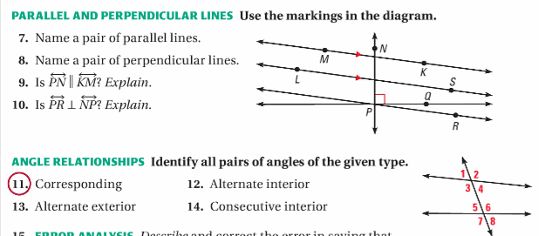

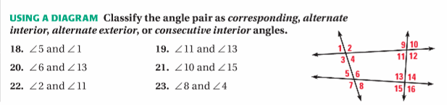

Lesson 4 Homework  BACK PAGE | LT 3.1,3.2 | 7-14, 18-21 (FRONT)  5-13 odd, 16-19, 28, 31, 33 (BACK)

